**SRILANKA INSTITUTE OF ADVANCED TECHNOLOGICAL EDUCATION (SLIATE) ATI JAFFNA**



**ONLINE GROCERY MRKET FOR SUPAS TRARS**

**PROJECT PROPOSAL**

**2024**

Gnanachandran Supasthikan  
HNDIT  
JAF/24/F/IT/1296

Contents  
THE

1. ABOUT THE SYSTEM 4
2. AIMS AND OBJECTIVES 6

Ø **Aims** 6

Ø**Objective** 7

3) PROJECT DETAILS 7

4) STATEMENT OF PROBLEM 8

5) HARDWARE & SOFTWARE REQUIREMENTS 8

Ø**Software Requirements:** 8

Ø**Hardware Requirements:** 9

Ø**Other Requirements:** 9

6) GANT CHART 10

7) SCHEDULE 10

8) APPROVAL. 10

**ONLINE GROCERY MRKET FOR SUPAS TRARS PROPOSAL  
  
CANDIDATE DETAILS**

* Name: Gnanachandran Supasthikan
* Admission no: JAF/24/F/IT/1296
* Academic year: 2024
* Address: Kopay North Kopay
* Email: [gsupasthikan@gmail.com](mailto:gsupasthikan@gmail.com)
* Phone no: 0776775242

**SUPERVISOR DETAILS**Name: Kajan

* **Functional Requirements**
* customer can be able to view grocery items
* admin can be abile to grocery items
* customer can be able to select his favourable vegetable items and make can order
* system sends the customer Oder notification and admin
* customer can be able to view the management reports

# **ABOUT THE SYSTEM**

**The Vegetable Online Marketing Platform** is designed to offer a modern, user-friendly, and visually appealing online experience that enhances the marketing and sales of fresh vegetables. This system aims to attract more customers, streamline orders, and effectively showcase the variety and quality of vegetables available.

**Key Elements:**

1. **Modern User Interface**: The website features a contemporary design, crafted with HTML and CSS, to ensure an engaging and intuitive user experience.
2. **Enhanced Online Presence**: By leveraging modern web design practices, the platform aims to boost the visibility and appeal of vegetable offerings to potential customers.
3. **Streamlined Ordering Process**: The system simplifies the process of browsing and purchasing vegetables, making it efficient for customers to place orders and for the business to manage them.
4. **Showcasing Offerings**: The website highlights a diverse range of fresh vegetables, including seasonal specials and popular varieties, allowing customers to see all available options at a glance.
5. **Mobile Responsiveness**: In today’s mobile-centric world, the website is designed to be fully responsive, ensuring that customers have a smooth and enjoyable experience whether they are using a smartphone, tablet, or desktop computer.

**Objectives:**

1. **Attract More Customers**: By providing a modern and engaging online platform, the website is aimed at drawing in more customers who are interested in purchasing fresh vegetables conveniently.
2. **Simplify Online Vegetable Sales**: The platform is designed to streamline the process of setting up an online vegetable market, making it easier for businesses to reach and serve their customers.
3. **Showcase Freshness and Variety**: Emphasizing the quality and variety of vegetables helps in engaging customers and encouraging them to explore and purchase different types of produce.
4. **Optimize for Mobile Users**: Ensuring the site is mobile-friendly addresses the growing trend of mobile device usage, making it easier for users to browse and buy vegetables on the go.

By focusing on these aspects, the vegetable online marketing platform aims to exceed customer expectations while supporting the goals of businesses in the fresh produce industry.

# **AIMS AND OBJECTIVES**

**Aims**

• **Enhance Customer Engagement:** To create a visually appealing and interactive website that attracts and retains customers by showcasing fresh vegetables in an engaging manner.

• **Streamline the Purchasing Process:** To simplify the online buying process, making it efficient for customers to browse, select, and purchase vegetables with ease.

• **Showcase Vegetable Variety:** To effectively highlight the diversity and quality of vegetable offerings, including seasonal specials and popular varieties.

• **Optimize for All Devices:** To ensure the website is mobile-responsive, providing a seamless shopping experience across smartphones, tablets, and desktop computers.

• **Support Business Growth:** To provide a robust platform that facilitates the growth of vegetable marketing businesses by enhancing their online presence and operational efficiency.

## 

## **Objective**

• **Modernize User Experience:**

* Design a user-friendly interface using HTML and CSS to enhance visual appeal and navigation.
* Implement responsive design principles to ensure the website performs well on all devices.

• **Improve Online Visibility:**

* Utilize SEO best practices to increase search engine rankings and drive more traffic to the site.
* Create engaging content and visuals to attract and inform potential customer

• **Facilitate Easy Ordering:**

* Develop a streamlined ordering system that allows customers to easily select and purchase vegetables.
* Integrate secure payment options and user-friendly checkout processes to enhance convenience.

• **Highlight Quality and Freshness:**

* Use high-quality images and detailed descriptions to showcase the freshness and variety of vegetables.
* Feature seasonal and special vegetable promotions to attract interest and encourage purchases.

**PROJECT DETAILS**

* Website System For Vegitables Marketing
* Shoping Cart
* Friendly Interface
* Mobile Response

# **STATEMENT OF PROBLEM**

• **Lack of Visibility and Accessibility:** This limits their ability to reach a broader audience and effectively showcase their products, especially in a competitive market where visibility is crucial.

• **Complex Ordering Process:** Consumers often encounter difficulties when purchasing vegetables online due to complex or non-intuitive ordering systems.

• **Inconsistent Product Presentation:** Vegetables are perishable items that require effective presentation to convey their freshness and qualit.

• **Limited Marketing and Promotion:** Vegetable sellers may lack effective online marketing strategies and promotional tools, which are essential for attracting new customers and retaining existing ones. Without these, businesses may struggle to grow their online presence and drive sales.

**HARDWARE & SOFTWARE REQUIREMENTS**

## **Software Requirements:**

* **Operating System**:
  + Microsoft Windows 10 or higher
* **Programming Languages**:
  + HTML5: For structuring the web pages.
  + CSS3: For styling and responsive design.
  + JavaScript: For interactive elements and client-side scripting.
* **Web Browser**:
  + Google Chrome
  + Firefox
* **Integrated Development Environment (IDE)**:
  + HTML

## **Hardware Requirements:**

* **CPU**:
  + Intel Core i3 or higher
* **RAM**:
  + 8GB minimum (16GB recommended for better performance)
* **Hard Drive**:
  + 256GB SSD minimum (512GB SSD recommended for faster performance)
* **Network**:
  + High-speed broadband connection for development and testing.
* **Other Requirements:**
* **Knowledge**:
  + Proficiency in web design principles and responsive design.
  + Understanding of SEO best practices for better search engine visibility.
  + Experience with web security protocols (e.g., HTTPS, SSL/TLS).

# **GANT CHART**

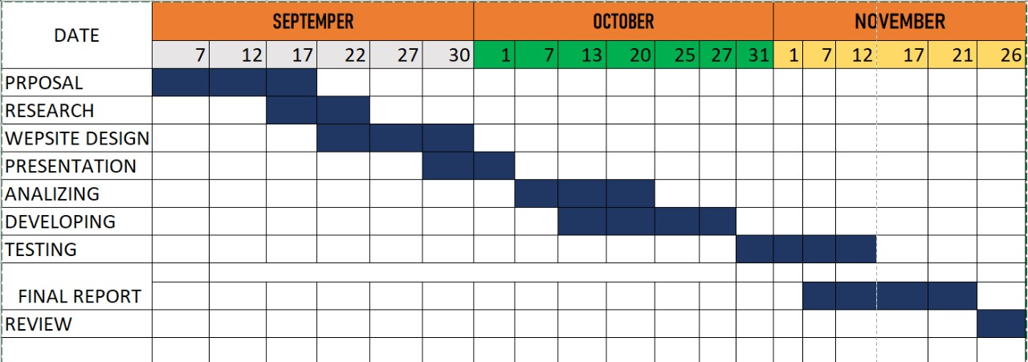

# **SCHEDULE**

|  |  |
| --- | --- |
| **ITEM** | **DATE** |
| Proposal | 2024/09/07 |
| Reseach | 2024/09/17 to 2024/09/22 |
| Wepsite Design | 2024/09/23 to 2024/09/30 |
| Presentation | 2024/09/1 |
| Analizing | 2024/09/7 to 2024/09/20 |
| Developing | 2024/09/13 to 2024/09/27 |
| Testing | 2024/09/31 to 2024/09/12 |
| Final Report | 2024/09/1 to 2024/09/21 |
| Review | 2024/09/26 |

# **APPROVAL** I certify that this project is being done under my supervision and has been approved.

………………………………..

(Project Supervisor)